**United Methodist Committee on   
Deaf and Hard of Hearing   
Ministries Committee**  
Contact the committee to learn more and for more information. Also, enroll to receive our quarterly newsletter. The newsletter includes resources, best practices, national and local Deaf ministry news, and other information.  
www.umdeaf.org

**UNITED METHODIST COMMITTEE ON DEAF AND HARD OF HEARING MINISTRIES**

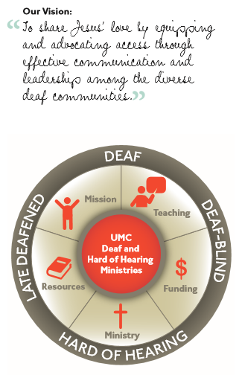

Check out our sister committee,   
Disability Ministries Committee   
of The United Methodist Church www.umcdmc.org  
decorative border  
 **Additional Resources**

For additional congregational resources, visit the United Methodist Congress of the Deaf’s website   
at www.umdeaf.org.

A helpful resource is *Deaf Ministry: Ministry Models for Expanding the Kingdom of God, 4th Ed* by Leo Yates, Jr. It can be purchased at Amazon.com.

“To share Jesus’ love by equipping and advocating access through effective communication and leadership among the diverse  
Deaf communities.”

**Tips for Working with a Sign Language Interpreter**



**United Methodist Committee on Deaf and Hard of Hearing Ministries**

**Global Ministries**  
The United Methodist Church

**General Board of Global Ministries**

**The United Methodist Church**

**458 Ponce De Leone Ave NE**     
**Atlanta, GA 30308**

**www.umcmission.org**

**United Methodist Committee on Deaf and Hard of Hearing Ministries**  
www.umdeaf.org

**United Methodist Association of   
Ministers with Disabilities**  
https://amdumc.wordpress.com/

**Disability Ministries Committee  
of The** **United Methodist Church**  
www.umcdmc.org

**The United Methodist   
Congress of the Deaf**  
www.umcd.org

**How to Support the Committee  
Give to the Advance:**By Check:  
Make payable to “Advance GCFA.” Be sure to write Advance #982562 and “Deaf and Hard of Hearing Ministries” on the check. Send Checks to   
The Advance  
458 Ponce De Leon Ave, NE  
Atlanta, GA 30308  
  
By Credit Card:  
Call 1-888-252-6174 or go to www.umcmission.org/Give and search for Advance #982562.

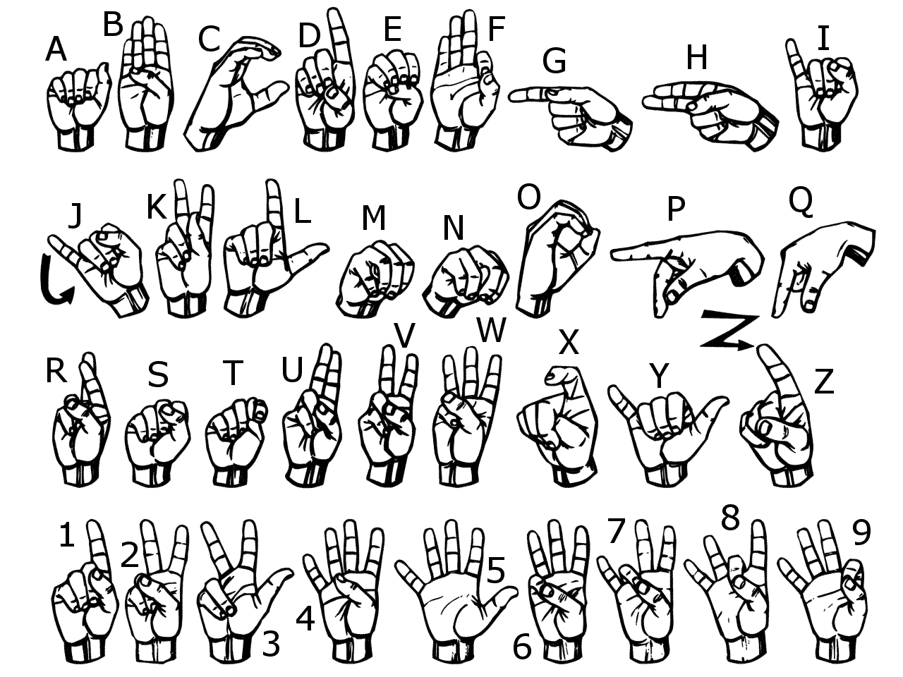

**The United Methodist Committee on   
Deaf and Hard of Hearing Ministries** is a Global Ministries committee. The committee provides resources, consultation, cultivates Deaf ministries, educates congregations, helps to develop Deaf leaders, and offers grants to United Methodist churches. Helpful to know is when reading a capital ‘D’ in the word deaf, it indicates cultural deafness within what is discussed or stated. Besides indicating hearing loss, the small ‘d’ in deaf indicates someone who is not culturally Deaf.

**Sign Language Interpreters**

A sign language interpreter is someone who interprets in sign language effectively, accurately, and proficiently, both receptively and expressively. Working in a Christian setting like a church, most interpreters will know or are willing to learn necessary specialized vocabulary. Some states require the interpreter to be credentialed (certified, screened, or licensed), while other states do not require it. Check with your state or by checking the Registry of Interpreters for the Deaf, Inc. (RID) website ([www.rid.org](http://www.rid.org)).  
  
An interpreter should demonstrate ethical interpreting skills and have the knowledge and expertise required to function in a professional capacity. Effective communication between individuals is the overall goal of interpreting, as the interpreter interprets for both Deaf and hearing consumers. For some churches, the norm is to have one interpreter for a typical 60-minute worship service, where a team of interpreters will be the norm for other churches. In some cases, the complexity of a service or event will warrant a team of interpreters. Length of time interpreters can work alone, and other standards may vary slightly by the geographical area. Provide preparation materials as needed. ………………

**Recruiting Interpreters**

Like in other professional settings, interpreters are paid, though; some will donate his or her services to his or her church. Some interpreters feel comfortable working in a church setting, but others do not due to not being familiar with the vocabulary and nuances it can have. Relying on family members to interpret is not recommended.

Interpreters are expected to be paid regardless of if Deaf and hard of hearing persons are not present or do not show. Some will require full payment, while others may reduce the fee, which will cover their time and expense for traveling. Churches vary in their hiring practices, which can include hiring the interpreter as a part-time staff interpreter, hiring the interpreter as a contractor (a 1099 employee), or through volunteer recruitment efforts. Time of payment also vary, which can include the day the services were provided, within 2-4 weeks, or within 30 days. Paying an interpreter on the day services are provided may entice an interpreter to accept the request. Interpreters charge by the hour with a 2-hour minimum (standard) or a flat fee for the service. A 2-hour minimum typically includes the services provided and the preparation time. Reimbursement for travel (mileage) is also the norm.

**Hiring an Interpreter**

Hiring an interpreter through an interpreting agency is more expensive, where hiring the interpreter directly is less expensive. Keep in mind, often when a person(s) utilizing the interpreter will tithe and this can help cover part or all of the cost of the interpreter (but do not put the burden of paying the interpreter on the Deaf person). Churches will want to budget for the costs, do fundraising, and/or take up a special offering one or more times a year.

Some areas have a plethora of interpreters, where others are scarce. Recruitment ideas are:

1. Contact an interpreting agency in your area.
2. Contact the state Vocational Rehabilitation (VR) office, as they will likely have resource information.
3. Contact the state Deaf and Hard of Hearing Commission/Office/Coalition for referrals.
4. Go to the Registry of Interpreters for the Deaf (RID) website and search for interpreters on their online directory (freelance interpreters may be less expensive instead of an agency).
5. Research nearby colleges and schools and ask their department of disability support services for a possible referral. If there is a sign language interpreting program, contact the department about recommending an interpreting student.
6. Contact other Deaf ministries to inquire.

**Requesting Interpreting Services**

Be prepared to provide the following:

1. The date, time, and the length of the event (e.g., worship service).
2. The church name and address.
3. The requestor’s name, title, and contact information.
4. Type of payment and arrangements (e.g., PayPal, credit card, check).
5. The name of the person needing the services (e.g., the Deaf person).
6. To give a general description of the event (e.g., traditional worship service).
7. Preparation materials (e.g., bulletin, sermon, music, Scriptures, etc.).
8. On-site contact person’s name and phone/text number.
9. Ensure faith leaders or the pastor is aware.