**United Methodist Committee on   
Deaf and Hard of Hearing   
Ministries Committee**  
Contact the committee to learn more and for more information. Also, enroll to receive our quarterly newsletter. The newsletter includes resources, best practices, national and local Deaf ministry news, and other information.  
www.umdeaf.org

“To share Jesus’ love by equipping and advocating access through effective communication and leadership among the diverse  
Deaf communities.”

**UNITED METHODIST COMMITTEE ON DEAF AND HARD OF HEARING MINISTRIES**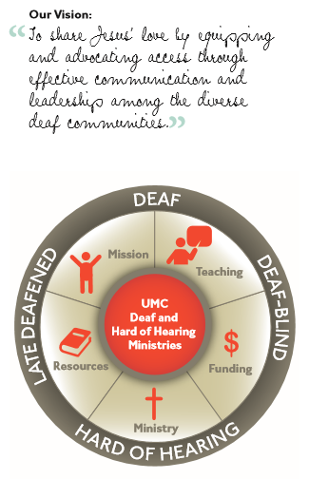

Check out our sister committee,   
Disability Ministries Committee   
of The United Methodist Church www.umcdmc.org  
decorative border  
 **Additional Resources**

For additional congregational resources, visit the United Methodist Congress of the Deaf’s website at www.umdeaf.org.

A helpful resource is *Deaf Ministry: Ministry Models for Expanding the Kingdom of God, 4th Ed* by Leo Yates, Jr. It can be purchased at Amazon.com.

**Guidance for Implementing a Deaf Ministry**



**United Methodist Committee on Deaf and Hard of Hearing Ministries**

**Global Ministries**  
The United Methodist Church

**General Board of Global Ministries**

**The United Methodist Church**

**458 Ponce De Leone Ave NE**     
**Atlanta, GA 30308**

**www.umcmission.org**

**United Methodist Committee on Deaf and Hard of Hearing Ministries**  
www.umdeaf.org

**United Methodist Association of   
Ministers with Disabilities**  
https://amdumc.wordpress.com/

**Disability Ministries Committee  
of The** **United Methodist Church**  
https://umcdmc.org

**The United Methodist   
Congress of the Deaf**  
www.umcd.org

**How to Support the Committee  
Give to the Advance:**By Check:  
Make payable to “Advance GCFA.” Be sure to write Advance #982562 and “Deaf and Hard of Hearing Ministries” on the check. Send Checks to   
The Advance  
458 Ponce De Leon Ave, NE  
Atlanta, GA 30308  
  
By Credit Card:  
Call 1-888-252-6174 or go to www.umcmission.org/Give and search for Advance #982562.

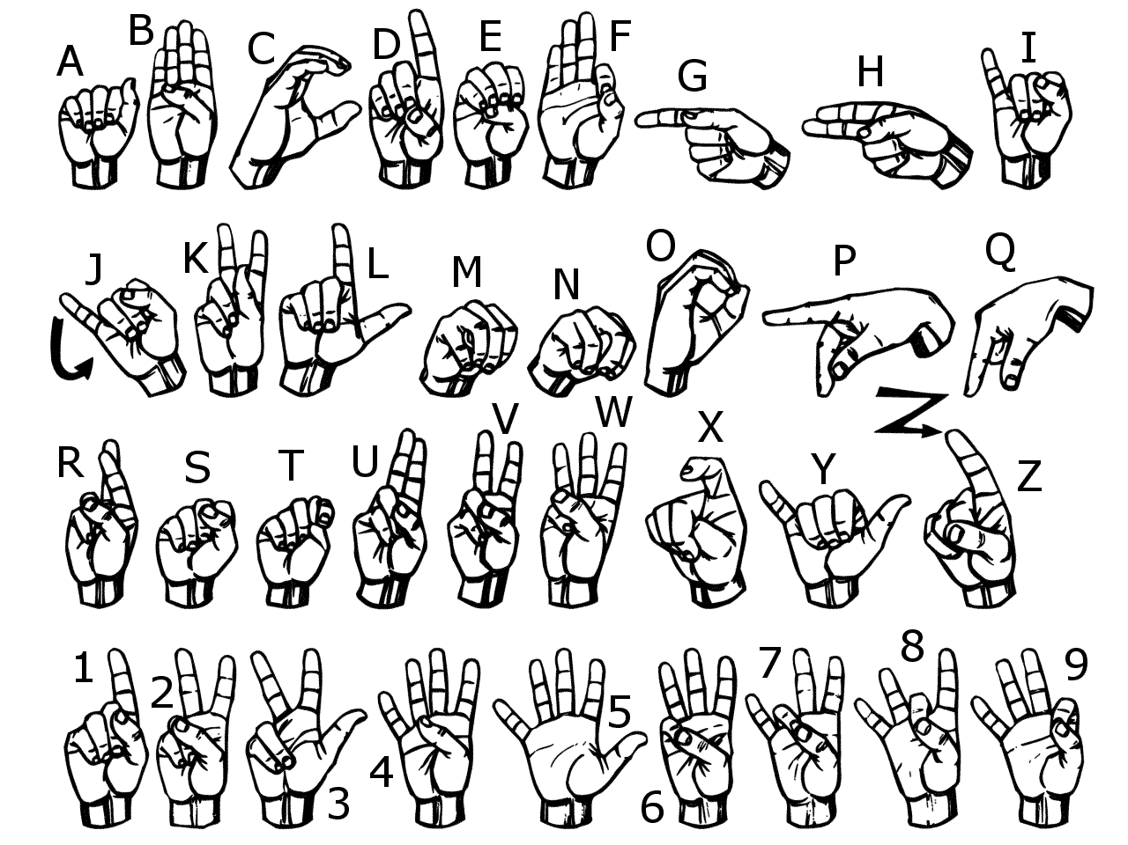

**The United Methodist Committee on   
Deaf and Hard of Hearing Ministries** is a Global Ministries committee. The committee provides resources, consultation, cultivates Deaf ministries, educates congregations, helps to develop Deaf leaders, and offers grants to United Methodist churches. Helpful to know is when reading a capital ‘D’ in the word deaf, it indicates cultural deafness within what is discussed or stated. Besides indicating hearing loss, the small ‘d’ in deaf indicates someone who is not culturally Deaf.

**What is a Deaf Ministry?**

Deaf ministry is an umbrella term for doing ministry with Deaf, hard-of-hearing, late-deafened, and Deaf-blind individuals and their families. In general, Deaf ministry is often used as a sweeping term that means a church has a ministry with Deaf, hard-of-hearing, late-deafened, and Deaf-blind people, often by welcoming, providing care, in ministry with, and including in the life of the church. In addition, it is also seen as a church program that is inclusive of Deaf people. At the heart of a Deaf ministry are the relationships that are made and the collaboration among other ministries. Be sure to contact the United Methodist Committee on Deaf and Hard of Hearing Ministries for free consultations and resources. Remember, Deaf ministry is more than accessibility; it is a cultural shift that includes cultural awareness, cultural knowledge, and cultural sensitivity.

**Implementing a Deaf Ministry**

Whenever beginning any ministry, it should always begin with prayer. Understanding the motivation behind the desire is essential to be sure it is starting off on the right foot. Ideally, it’s a calling or a community need, while desiring to “save the deaf people” will be a cause for concern.

Some planning suggestions include:

1. Pray. Pray for insight, for volunteers, for your church’s desire to such a ministry.
2. Enlist leadership support. Having the pastor’s and/or the church council is vital.
3. Establish a team or committee. A team is at the heart of any successful ministry. Gather a core team to oversee the development of the Deaf ministry. Develop a plan.
4. Begin small. Utilize the resources and the people God provides and start from there.
5. Educate the team and congregation. Perhaps bring in a consultant to help guide your committee to see which ministry model is right for your church.
6. Ministry models. There are several ministry models, such as, (a) Deaf missions (b) interpreted ministry (c) hard of hearing ministry (stresses accessibility, inclusion, and empowerment), (d) multicultural model, and (e) Deaf-blind ministry. The *Deaf Ministry: Ministry Models* *for Expanding the Kingdom of God, 4th Ed.* (Leo Yates, Jr.) provides an overview of the models.
7. Adjust and grow the ministry. If the plan is not working, try something new. Sometimes a Deaf ministry only has 1 or 2 Deaf people – and that’s okay! Remember to do periodic reviews (e.g., the church’s hospitality and accessibility).

**Common Barriers**

There are common barriers to growing a Deaf ministry. Some barriers include:

1. Communication barriers, such as not having an interpreter or one who is not proficient at signing; not using a sound system or offering assisted listening system; or not offering large print bulletins or materials.
2. Programmatic barriers. Inviting people may not be the problem, but perhaps not having transportation to church is. Or not having access to interpreters beyond the worship service.
3. Attitudinal barriers can be words that are demeaning, condescending, and/or paternalistic.
4. Audism is a negative bias towards Deaf and hard of hearing people, such as racism is to people of color.
5. Funding, or the lack thereof, is often a reason why Deaf ministries do not get off the ground. Being able to pay the interpreter or get special equipment. God can provide and be sure to pray for this aspect of the ministry.

**Promoting the Ministry**

There are a number of ways to promote the Deaf ministry. Promotion ideas include:

* At an audiologist’s office
* On the church website
* At an Ear, Nose, & Throat doctor’s office
* Promoting it at a hearing aid center
* Your conference/dioceses e-news blast
* Senior centers
* Your state association of the Deaf (www.nad.org/members/state-association-affiliates/)
* Your state vocational rehabilitation office
* Your state chapter of the Alexander Graham Bell Association for the Deaf and Hard-of-Hearing (www.agbell.org)
* Your state Deaf government agency (http://nasadhh.org/usa-roster/)
* On Facebook and other social media
* By offering a sign language class
* With other senior groups or older adult ministries