UNITED METHODIST COMMITTEE ON DEAF AND HARD OF HEARING MINISTRIES

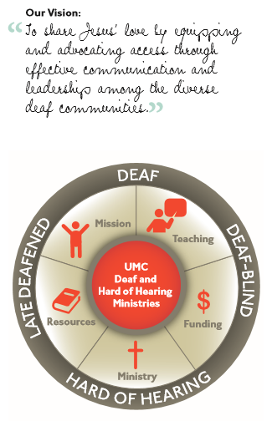

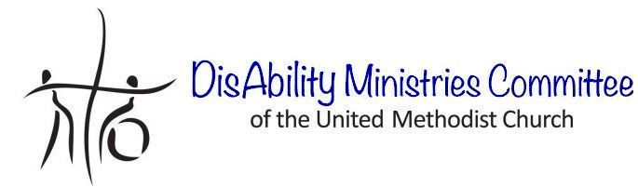
Check out our sister committee,
DisAbility Ministries Committee
of The United Methodist Church www.umdisabilityministries.org
Additional Resources
For additional congregational resources, visit the United Methodist Congress of the Deaf’s website
at www.umdeaf.org.
A helpful resource book is
Deaf Ministry: Ministry Models
for Expanding the Kingdom of
God, 2nd Ed by Leo Yates, Jr.
“To share Jesus’ love by equipping and advocating access through effective communication and leadership among the diverse
Deaf communities.”
United Methodist Committee on
Deaf and Hard of Hearing
Ministries Committee
Contact Rev. Leo Yates, Jr. at leoyjr@gmail.com for additional information or for a consultation. Also, contact him to receive our quarterly newsletter. The newsletter includes resources, best practices, national and local Deaf ministry news, and other information.
www.umdeaf.org

Guidance for Learning
Deaf Culture and
Sign Language
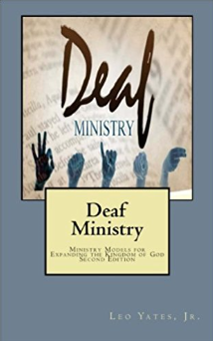
United Methodist Committee on Deaf and Hard of Hearing Ministries
Global Ministries
The United Methodist Church
General Board of Global Ministries
The United Methodist Church
458 Ponce De Leone Ave NE
Atlanta, GA 30308
www.umcmission.org

United Methodist Committee on Deaf and Hard of Hearing Ministries
www.umdeaf.org
United Methodist Association of Ministers with Disabilities
www.umdisabledministers.org
DisAbility Ministries Committee
of The United Methodist Church
www.umdisabilityministries.org
The United Methodist
Congress of the Deaf
www.umcd.org
How to Support the Committee
Give to the Advance:
By Check:
Make payable to your local church or “Advance GCFA.” Be sure to write Advance #982562 and “Committee on Deaf and Hard of Hearing Ministries” on the check. For local church and annual conference credit, give your gift to your local church treasurer.
By Credit Card:
Call 1-888-252-6174 or go to www.umcmission.org/Give-to-Mission/Give-to-Mission and search for Advance #980562.

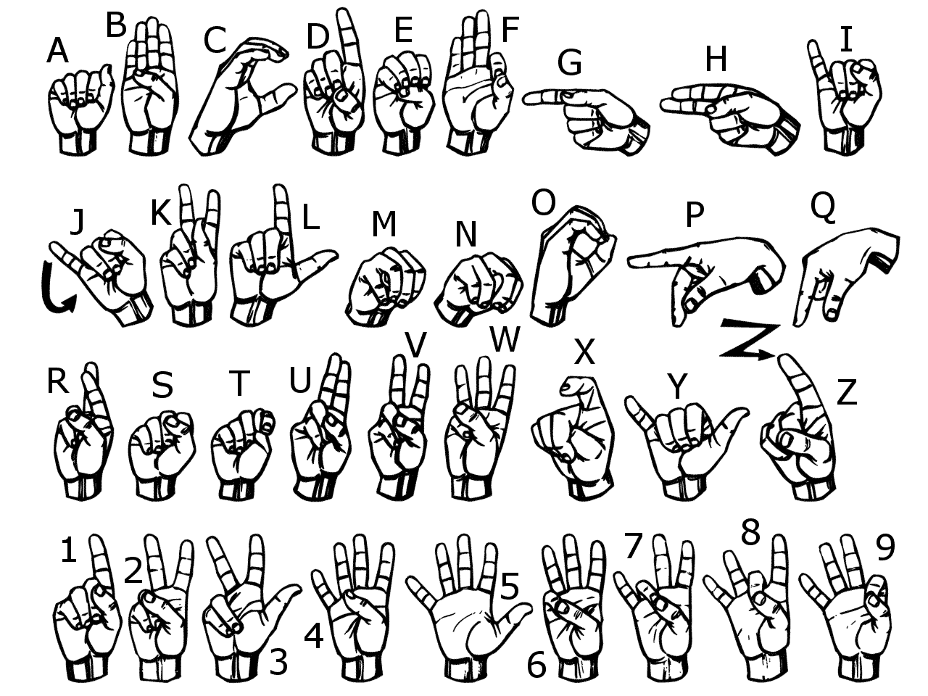
The United Methodist Committee on
Deaf and Hard of Hearing Ministries is a Global Ministries committee. The committee provides resources, consultation, cultivates Deaf ministries, educates congregations, helps to develop Deaf leaders, and offers grants to United Methodist churches. Helpful to know is when reading a capital ‘D’ in the word deaf, it indicates cultural deafness within what is discussed or stated. Besides indicating hearing loss, the small ‘d’ in deaf indicates someone who is not culturally Deaf.
Deaf Culture
Deaf people do not perceive themselves as having lost something (i.e., hearing) and do not think of themselves as handicapped, impaired, or disabled. They celebrate and cherish their culture because it gives them the unique privilege of sharing a common history. This is at the heart of the Deaf community, along with sign language.

As with any culture, there are shared values, beliefs, and experiences that people have in common. This holds true for many people in the Deaf community. They have their own culture with a language and identity; most will identify as Deaf or hard of hearing. There are many sub-cultures: in the United States, among others there are Deaf poetry, Deaf African American history and traditions, Deaf Latino history and traditions. When referring to Deaf people, simply say Deaf and hard of hearing, as “hearing impaired” is often considered a negative label.
Sign Language
As with other cultures and their languages, Deaf culture and American Sign Language (ASL) have their own history, and have been passed from one generation to the next in schools and communities. Like spoken languages, sign language is not universal, but is often distinguished by country and even has nuances by region or area. It is an expressive, beautifully complex language that includes visual, gestural, and spatial components. As a language, it includes facial expressions and body language as integral parts of the communication process.
Sign Language Classes
One way to help a hearing congregation to be more aware and inclusive of Deaf, hard of hearing, late-deafened, and Deaf-blind people is to offer a sign language class. Ideally, have a Deaf, hard of hearing, or a Deaf-blind person teach it since it is his or her language. Four to six week classes are good for introduction, but can be longer or shorter as needed.
If a Deaf, hard of hearing, or a Deaf-blind person is not available to teach the class, one option is to consider online classes. Some are FREE. A few online sign language classes include the following:
ASL University - This is one of four free ASL courses offered online by ASL University. Courses are separated into six units that include quizzes, numbers practice and fingerspelling practice activities. Most lessons consist of objectives, vocabulary, practice sentences and stories for translation.
www.asluniversity.com
Start ASL - This is the second in a series of three progressive ASL courses. Training includes fingerspelling, reading assignments, videos, conversion sentences and various tips for perfecting skills. These courses cover topics in numbers, grammar, vocabulary and comprehension.
www.startasl.com
Lesson Tutor - ASL for the Deaf is an ASL training program offered in three series that consist of 12 lessons each. Along with an explanation article, each lesson also presents visual diagrams on proper ASL form. Worksheets are available to demonstrate training. Students can utilize Lesson Tutor's ASL dictionary to translate additional signs.
www.lessontutor.com/ASLgenhome.html
Expert Village - Sign Language Lessons: Common Phrases is separated in 15 parts, and all training is offered through videos that are 2-3 minutes long. These videos teach students to emphasize sign images, body language and facial expression while signing.
Search YouTube by using Expert Village.
UMC ASL Glossary is a United Methodist video glossary.
www.umc.org/what-we-believe/glossary
Promoting the Class
Consider promoting the class at:
* Senior centers * Libraries
* Coffee places * Audiology offices
* Ear, Nose, & Throat * Through social media
doctor’s offices * At preschools
* Hearing aid centers * Online newspapers
Additional considerations: Host an ASL Day event with resource tables (an ABCs table, sign phrases, Deaf culture, and gesturing), hosting a silent dinner, or a music workshop (signing music).

